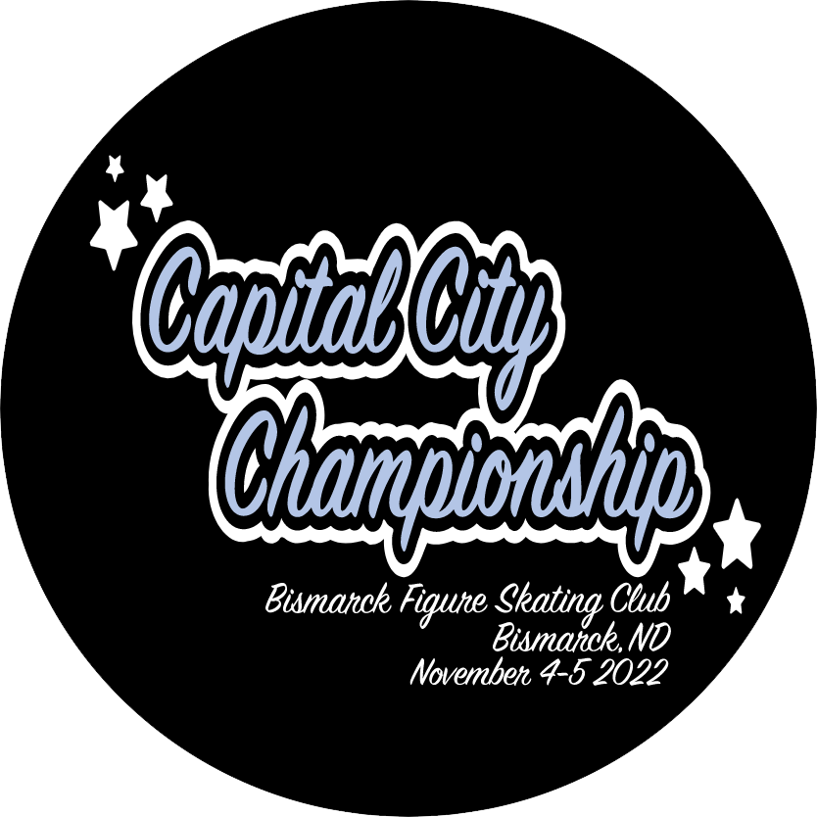
The 13th Annual

Capital City Championships

Hosted by
The Bismarck Figure Skating Club

November 4th – 5th, 2021

Capital Ice Complex
1504 Wichita Dr.
Bismarck, ND 58504

The 13th Annual Capital City Championship Figure Skating Competition will be conducted in accordance with the rules and regulations of U.S. Figure Skating, as set forth in the current rulebook, as well as any pertinent updates that have been posted on the U.S. Figure Skating website.

This competition is open to all eligible, restricted, reinstated or readmitted persons as defined by the Eligibility Rules, and who are currently registered member of a U.S. Figure Skating member club, a collegiate club or who is an individual member in accordance with the current rulebook. Please refer to the current rulebook for non-U.S. citizens.

Covid Information:
As of March 15, 2022, and consistent with updated CDC guidance on mask use, Face coverings are no
longer required to be worn indoors at U.S. Figure Skating-sanctioned events or activity if Burleigh/Morton
community levels are Low or Medium. We do encourage masks to be worn indoors if Burleigh/Morton community is in the High category based on the CDC Community Levels by County Map.

- PLEASE NOTE THAT THIS ANNOUNCEMENT MAY BE SUBJECT TO CHANGE PER THE
CURRENT COVID REGULATIONS AT THE TIME OF THE COMPETITION. CHECK THE
BISMARCK FIGURE SKATING CLUB WEBPAGE FOR ANY UPDATES TO THE
ANNOUNCEMENT.

ELIGIBILITY/TEST LEVEL:
Test Level: Competition level is the highest test passed as of the entry deadline in the discipline the skater is entering. Entrants may skate up one level above that for which they qualify, but they may not skate down in any event.

Skaters entering pre-juvenile and lower events will be divided as closely as possible by age should the number of entries warrant more than one group.

COMPETITION REGISTRATION:
Online registration is available via secured credit card transaction on http://comp.entryeeze.com/Home.aspx?cid=353

Entry deadline is 11:59PM October 3th, 2022. Upon receiving your application online an email will be sent to the skater's coach to verify accuracy of entry. An official at the skater's home club will also be notified to certify the skater's standing with the club. The LOC will email a preliminary grouping of all entrants as designated by the chief referee, which will be sent to ALL registered coaches. Coaches will have 48 hours to make any changes without penalty. After the 48 hours, changes can be made, but a penalty would apply. Notification of competition and practice ice times will be sent by email.

NOTE: In the event that a skater is signed up for the incorrect level or event, the Chief Referee must approve all changes. A $25 CHARGE WILL BE MADE FOR CORRECTING ANY MISTAKE MADE. READ THE RULES and DESCRIPTIONS CAREFULLY. NO CHANGES WILL BE MADE ONCE THE COMPETITION SIGN IN PROCESS BEGINS.

Fees will be as follows:
USFSA Non-Qualifying Event Fees:
$100 first event (per competitor)
$40 for each additional event (per competitor)
LTS Compete USA Fees:
$50 first event (per competitor)
$30 for each additional event (per competitor)

LATE ENTRIES: Late entries will be accepted only at the discretion of the Chief Referee and must be accompanied by a $50.00 late fee

FOREIGN SKATERS:
Non-U.S. skaters intending to register for this competition must set up a non-member account prior to registering for the competition (click here for HOW TO). This can be done by choosing the “Create Account (Non-Member)” option on the Members Only login page.

MANDATORY ATHLETES:
Athletes age 18+ as of the competition start date who will be competing on a team (i.e. synchro, dance, pairs, shadow dance, theatre, etc.) with at least one minor athlete must complete SafeSport training. *

Minor Athletes who turn 18 mid-season are encouraged to seek parental consent to take the online SafeSport training early to avoid any disruptions in their ability to participate as the training is required upon turning 18. The athlete will not be SafeSport compliant until they have completed the training and their Members Only portal reflects completion. Please email safesport@usfigureskating.org for instructions or questions regarding parental consent.

REFUND POLICY: Entry fees will not be refunded after October 3th, 2022 unless no competition exists or the event is canceled. There will be no refunds for medical withdrawals. The online processing fees are not refundable. Checks returned for non-sufficient funds and contested credit card charges will be issued a $25.00 fee. Payment of the fee will be required before the skater is allowed to participate in practice ice or events. Notification of competition and practice ice times will be available online at our Entryeeze page.

SCHEDULE: Competitors may be scheduled on any day or time during the announced dates of the competition. The competition and practice ice schedule will be available after the close of entries. All participants will be notified via email once available.

FACILITIES: The competition will be held at the Capital Ice Complex, 1504 Wichita Dr., Bismarck, ND 58504. The facility has two ice surfaces, each 85 x 200 feet, with modest seating capacity. The rink has fair temperatures but observers may want to bring warmer clothing. Locker rooms will be assigned to all competitors upon check in.

MUSIC SUBMISSION:
All events requiring music must be submitted electronically via the online registration system by the deadline of November 1st, 2021 @ 11.59pm.
- File Format: MP3
- Bit Rate: 192 kbps or higher and Sample Rate: 44,100 kHz
  - This will be verified by the music chair and they may request you upload a corrected file.
- Leaders and trailers (the silence or "dead space" before and after the actual start and end of the program music) may not exceed two (2) seconds. We prefer that there be NO leaders or trailers at all. Excessive leaders and trailers may disrupt the playing of the music during competition.

Competitors must also bring a copy of their competition music on digital copy (phone, ipod, or jump drive) as a backup in case of technical difficulties and must be available rink side during the competition.

LIABILITY: U.S. Figure Skating, Bismarck FSC and Capital Ice Complex accept no responsibility for injury or damage sustained by any participant in this competition. This is in accordance with Rule 1600 of the official U.S. Figure Skating Rulebook.

ONSITE REGISTRATION/CHECK-IN: Registration will begin 30 minutes prior to the first scheduled practice ice session of the competition. Registration will close 30 minutes after the end of the competition each day. The registration desk will be in the front lobby of the Capital Ice Complex. Please register promptly upon arrival. Results will be available for purchase at the registration desk once results are posted.

LOCKER ROOMS AND CHANGING AREAS:
Locker rooms and changing areas at U.S. Figure Skating competitive events are for athletes only, will be labeled with regard to specific use and where identified will be gender specific. An exception can be made for athletes 11 years old and younger that will allow for one parent of the same sex to assist their child immediately prior to and after their skating event(s). Please review the Locker Room and Changing Area Policy and the SafeSport Handbook (both found on the U.S. Figure Skating SafeSport page).

PRACTICE ICE: Practice ice will be available for purchase online via Entryeeze. Practice ice selection will open one week prior to the competition. Emails will be sent to notify when selection begins. Pre-paid practice ice is $14 for each 20-minute session. All sessions must be paid in advance. Additional practice ice will also be available once the competition registration desk is open at a cost of $16 per session. NO Refunds for unused practice ice sessions.

AWARDS: Awards will be given to top four skaters.

OFFICIAL NOTICES: An official bulletin board will be maintained in the main lobby. It is the responsibility of each competitor, parent and coach to check the bulletin board frequently for any schedule changes and/or additional information. Skaters are requested to arrive 45 minutes prior to the scheduled time of their event. A tentative schedule of events will be posted prior to the competition.

IMPORTANT NOTICE FOR ALL COACHES:
To be a credentialed coach at a sanctioned nonqualifying competition, coaches must meet the compliance requirements listed below and verified by the U.S. Figure Skating.

Coach/Choreographer (domestic/non-foreign):
- Must be a current full member of U.S. Figure Skating either through a member club or as an individual member.
- If 18 years or older, must submit information for, proper payment of $30 and successfully pass a background check. *
  - The background check will be valid for two seasons, the one in which it was completed plus one additional.
- If 18 years or older, must complete annual SafeSport Training. *
  - The training will be valid for 365 days from date of completion and there is no cost for the training/certification.
- Must complete the Professional Coach/Choreographer Coaching Education Requirement (CER) through the Professional Skaters Association (PSA).
- Must submit proof of general liability insurance with limits of $1 million per occurrence/ $5 million aggregate.
- Must agree to the U.S. Figure Skating Code of Ethics. *
- Must complete three waivers: 1) Assumption of Risk, Waiver and Release and Indemnification Agreement, 2) Medical Consent and 3) Name and Likeness Release and Consent Agreement. *
- If attending a qualifying competition or traveling as a part of Team USA and/or International Selection Pool (ISP), must be a full member of the Professional Skaters Association (PSA).

Learn to Skate USA Coach:
- Must be a current full member of U.S. Figure Skating either through a member club or as an individual member OR Learn to Skate USA instructor membership
- If 18 years or older, must submit information for, proper payment of $30 and successfully pass a background check. *
  - The background check will be valid for two seasons, the one in which it was completed plus one additional.
- If 18 years or older, must complete annual SafeSport Training. *
  - The training will be valid for 365 days from date of completion and there is no cost for the training/certification.
- Learn to Skate USA Instructor Certification completed OR U.S. Figure Skating compliance coach (details above)

Foreign Coach/Choreographer:
- Required to present the LOC with a letter from their federation verifying they are a member in good standing.

VOLUNTEER COMPLIANCE:
Reminder: compliant positions at all U.S. Figure Skating sanctioned events include key LOC members, locker room monitors and ALL medical event personnel. To be considered compliant, an approved volunteer serving in one of these positions must:

- Must submit information for, proper payment of $30 and successfully pass a background check*
  - The background check will be valid for two seasons, the one in which it was completed plus one additional
- Must complete annual SafeSport Training
  - The training will be valid for 365 days from date of completion and there is no cost for the training/certification *

* Accessible via U.S. Figure Skating Members Only website:
www.usfsaonline.org Person Icon or Account Member Profile Compliance

CONTACT INFO:
If you have questions, please contact:
Emily Zahn at bfscdirector@gmail.com
Farrah Gietzen at fairlah@hotmail.com

EVENT DESCRIPTIONS
SINGLES | JUDGING
Excel Free Skate (valid through September 2021) | 6.0
SPECIALTY | JUDGING
Compulsory Moves (No Test–Senior) | 6.0
Excel Compulsory Moves (Excel Beg.–Excel Prelim.) | 6.0
Jumps Challenge (Beginner–Senior) | 6.0
Spins Challenge (Beginner–Senior) | 6.0
SHOWCASE | JUDGING
Individual Entertainment (No Test – Senior, Adult) | CJS
SOLO DANCE | JUDGING
Solo Pattern Dance (not participating in series) | 6.0
FREE DANCE | JUDGING
Free Dance ( 2022 – 2023) | 6.0
COMPETE USA | JUDGING
Snowplow Sam-Basic 6 Program w/ Music | 6.0
Pre-Free Skate – Free Skate 1-6 Program w/ Music | 6.0
Snowplow Sam – Basic 6 Elements | 6.0
Pre-Free Skate – Free Skate 1-6 Compulsory Moves | 6.0
Compete USA – Showcase | CJS

